Requirement Elicitation, Verification, and Use Case Modelling for a Smart Campus System

An Assignment submitted in partial fulfillment of the requirements for the degree of
Bachelor of Science
in
Computer Science

CS 2401: Software Engineering 1
Term 5 – 2025
University of The People

September 17, 2025

Requirement Elicitation, Verification, and Use Case Modelling for a Smart Campus System
Introduction
In contemporary higher education, the integration of intelligent digital infrastructure is pivotal to fostering operational efficiency and enhancing the overall student experience. Universities worldwide are increasingly investing in Smart Campus Systems to automate administrative processes, boost engagement, and provide seamless access to campus services. The design and implementation of such complex systems require a rigorous approach to requirements gathering and validation, ensuring alignment with stakeholder needs and industry standards. This essay addresses the selection of appropriate elicitation techniques, methods to guarantee the quality of requirements, differentiation between functional and non-functional requirements, and the practical steps for developing a use case in Unified Modeling Language (UML) for a Smart Campus System, with an emphasis on stakeholder collaboration and real-world examples.
Elicitation techniques for university stakeholders
Gathering accurate and comprehensive requirements serves as the bedrock of successful system development. In the context of a Smart Campus System, I would employ interviews and workshops as the primary elicitation techniques.
Interviews
Interviews involve one-on-one or small group discussions with key stakeholders, such as Tutor members, administrators, and students. The interviewer prepares open-ended questions tailored to the specific needs and experiences of each stakeholder group (The Agile Business Analyst, 2021). Through interviews, the analyst can uncover nuanced insights into daily operational pain points and expectations for the new system. For example, when discussing online attendance tracking, a Tutor member might highlight current challenges with manual record-keeping, while students might express the desire for automated notifications upon successful check-in. This depth of qualitative feedback allows the analyst to develop a comprehensive list of user stories and use cases that reflect actual campus workflows.
Workshops
Workshops gather diverse groups of stakeholders in a collaborative environment to discuss and define system requirements collectively (The Agile Business Analyst, 2021). By facilitating structured discussions using whiteboards, sticky notes, or digital collaboration tools, the analyst ensures representation from all user groups. Workshops help to surface conflicting requirements, build consensus, and clarify ambiguities. For instance, a workshop on smart timetable generation would bring together Tutor, students, and scheduling staff to co-design the process, ensuring the final solution accommodates varying preferences and institutional constraints. This not only accelerates requirements gathering but also helps achieve buy-in from all parties.
These techniques, when employed together, ensure that the requirements gathered are both user-centric and comprehensive. Interviews provide depth and detail, while workshops promote alignment and consensus, meeting the needs of a diverse university community.
Validation and verification of the requirements
Once requirements are collected, their quality must be ensured through validation and verification. These two processes, though often used interchangeably, serve distinct purposes in software engineering. Verification answers the question, "Are we building the product right?" whereas validation asks, "Are we building the right product?"
Verification process
Verification focuses on confirming that the requirements are properly documented and comply with established specifications. This is typically achieved through structured reviews, walkthroughs, and desk checks (Summers, 2020). For example, after drafting the requirements for mobile-based navigation, the analyst conducts a peer review with the IT team to ensure the described functionality is technically feasible and aligns with platform standards. Verification checks for completeness by ensuring that all user scenarios are addressed, for consistency by checking that requirements do not contradict each other, and for achievability by validating that the requirements can be delivered within project constraints.
Validation process
Validation, on the other hand, ensures that the documented requirements truly reflect stakeholder needs and will deliver the intended value when implemented (Summers, 2020). This often involves stakeholder walkthroughs, prototyping, and user acceptance testing. For instance, a prototype of the smart timetable feature can be shared with a pilot group of students and Tutor. Their feedback might reveal that the initial design does not adequately support part-time student schedules, prompting revisions. Validation thus uncovers gaps between user expectations and system specifications before costly development begins.
Three examples illustrating verification and validation
Example 1: Verification through document review
Suppose the requirement states, "The system shall record attendance for every class session." During verification, the analyst checks that this requirement is clearly stated, unambiguous, and does not conflict with other requirements, such as privacy policies regarding data retention.
Example 2: Validation through stakeholder walkthrough
After developing a clickable prototype for the attendance tracking feature, a session is held with students and the Tutor. During the demonstration, stakeholders note that the mobile check-in process should include notifications for successful and failed attempts. This feedback is incorporated, validating that the requirement meets actual user needs.
Example 3: Achievability assessment
If the requirement specifies real-time campus navigation via mobile devices, verification involves consulting technical teams to ensure campus Wi-Fi infrastructure can support location tracking. If infrastructure is lacking, the requirement is revised for achievability, such as limiting real-time tracking to Wi-Fi-covered areas.
By combining these practices, the university ensures that requirements for the Smart Campus System are robust, achievable, and reflective of stakeholder priorities.
Functional and non-functional requirements
A clear distinction between functional and non-functional requirements is essential for effective system design.
Functional requirements
Functional requirements specify what the system should do. They describe the system’s behavior in response to user inputs and the interactions between users and the system (Jelvix, 2020). Two functional requirements for the Smart Campus System could include:
- Online attendance tracking: The system shall enable students to mark their attendance for each class session via a mobile application, and Tutor shall be able to view and export attendance records in real time.
- Smart timetable generation: The system shall automatically generate personalized timetables for students and tutors, factoring in course selections, classroom availability, and scheduling constraints.
These requirements focus on the core features and actions the system must perform to fulfill its primary objectives.
Non-functional requirements
Non-functional requirements define how the system should perform, focusing on attributes related to quality, performance, and user experience (Jelvix, 2020). Two non-functional requirements for the Smart Campus System might be:
- Usability: The system shall provide an intuitive user interface that enables new users to complete core tasks, such as marking attendance or accessing their timetable, within two minutes of first use.
- Reliability: The system shall maintain at least 99.5% uptime during academic periods, ensuring continuous access to critical campus functions.
Whereas functional requirements state what the system does, non-functional requirements set standards for how well those functions are executed.
UML Use Case Diagram for online attendance tracking
The UML Use Case Diagram for online attendance tracking provides a clear visualization of user interaction with the main features of the Online Attendance Tracking. Within the system boundary, ellipses represent essential functions, such as Mark Attendance, View Attendance Records, and Generate Attendance Reports, thereby making the system’s scope explicit. Student and Tutor actors are placed outside this boundary and are connected to their respective use cases. Students typically interact with Mark Attendance, while tutors have access to both View Attendance Records and Mark Attendance. The Admin actor oversees system operations and is linked to Generate Attendance Reports and Register New Students.
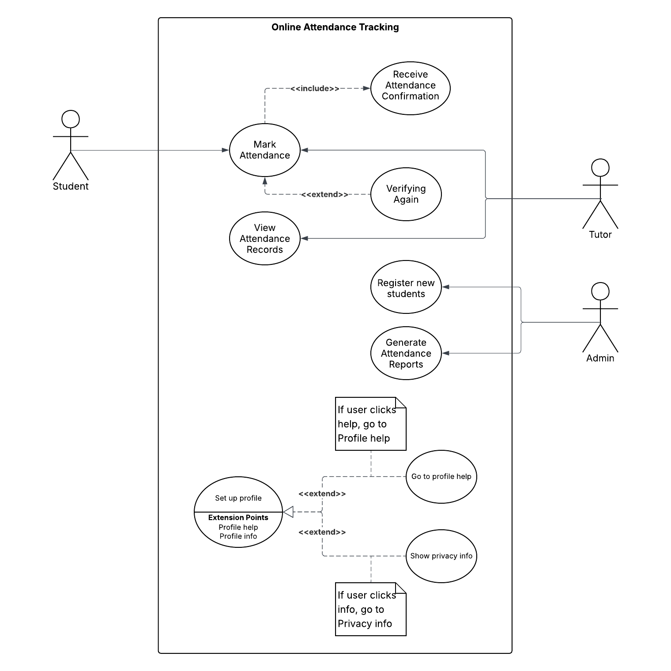
In addition to the attendance-related use cases, the Profile Setup use case introduces extension points to enhance user guidance and transparency. Two <> relationships are defined:
- Profile help: If the user clicks the help option during Profile Setup, the “Profile help” use case is invoked via a <> relationship. This offers contextual assistance, providing step-by-step instructions or guidance to help users complete their profile efficiently.
- Profile info: If the user clicks the info option while setting up their profile, the “Privacy info” use case is triggered through another <> relationship. This presents relevant information about privacy settings, helping users understand how their data will be used and protected within the system.
These extension points are clearly depicted in the diagram, branching from the main Profile Setup use case and leading to their respective additional use cases. This structure not only clarifies the possible user paths but also demonstrates the system’s commitment to user support and transparency.
The diagram further emphasizes key relationships. The Mark Attendance use case always leads to the Receive Attendance Confirmation sub-process, represented with an «include» relationship. This confirmation message is detailed, displaying the lesson subject and registration time. For example, a student might see, “Hello <Student’s name>, your registration attendance for physics lecture at 8:30 a.m. was successful.” An «extend» relationship captures the Verifying Again scenario, where students are prompted to retry attendance if the first attempt fails. This structured approach clarifies user roles, process flows, and system feedback, supporting ongoing system evolution and stakeholder communication.
Conclusion
Developing a Smart Campus System demands a comprehensive and collaborative requirements engineering process. Employing elicitation techniques such as interviews and workshops ensures that the needs and expectations of tutors, students, and administrators are adequately captured. The rigor of verification and validation processes is critical for delivering a system that is complete, consistent, and achievable. Differentiating between functional and non-functional requirements enables the design of a solution that is both effective and user-friendly. Finally, the use of UML use case diagrams provides a clear visualization of system interactions, supporting communication and alignment across stakeholder groups. By integrating best practices in requirements engineering and use case modeling, universities can successfully navigate the complexities of digital transformation, fostering innovation and engagement on smart campuses.

References
Jelvix. (2020, July 1). Functional vs non-functional requirements. [Video]. YouTube.
Summers, B. L. (2020). Effective methods for software engineering. Auerbach Publishers, Incorporated.
The Agile Business Analyst. (2021, May 1). Requirement gathering techniques for a business analyst [Video]. YouTube.

